# Connect Smith

Connect Smith aims to provide comprehensive and high-quality information services that enables students of the Robert H. Smith School of Business to access current alumni information and get a better insight into the real world and industry dynamics

## Getting Started:

These instructions will get you a copy of the project up and running on your local machine for development and testing purposes. See deployment for notes on how to deploy the project on a live system.

### Prerequisites:

**System Requirements**

There are no special requirements.  
  
**OS Support**  
Win7 x64, WinXP, WinVista, Win7 x32, Win8 x32, Win8 x64, Win10 x32, Win10 x64, Windows 8, Windows 10

**Steps to install and get started with Xampp on Windows**

1. Download Xampp from Apache friends.

<https://www.apachefriends.org/download.html>

Use the first link to download

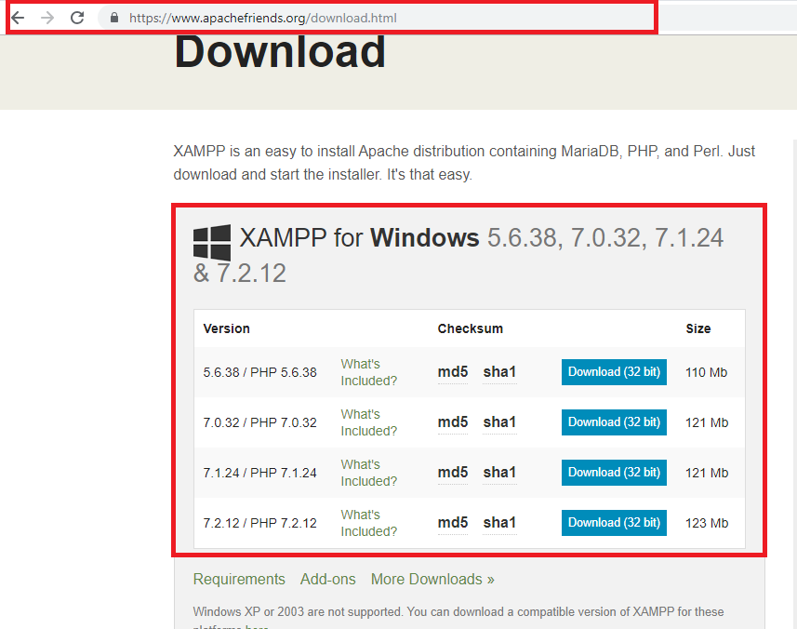

2**.** Double click on the file which is downloaded to run the installer.

In case a warning message appears, Click the OK or the YES button on the warning to continue.

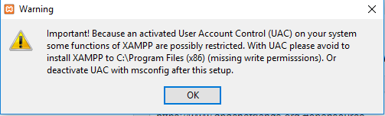

3. Click the **Next** button as shown below.

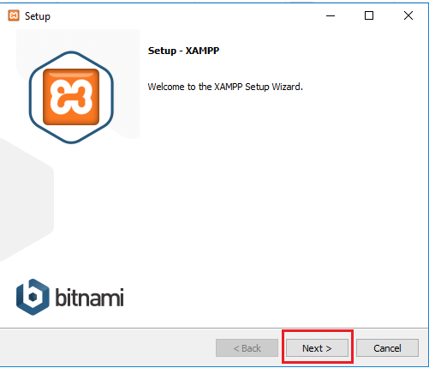

4. XAMPP offers a variety of components that we can install, such as MySQL, phpMyAdmin, PHP, Apache, and more. For the most part, most of these components will be used. Hence it is recommended to leave the default options and click the **Next** button.

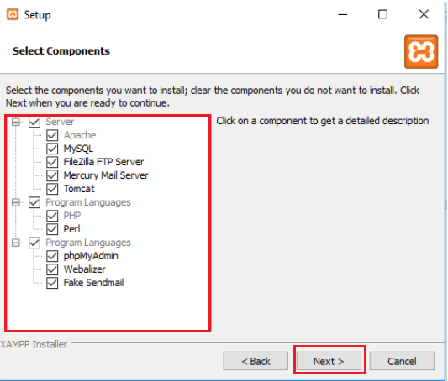

5. Use the default install location setting. You can also choose another folder or location to install the software. And then click the **Next** button.

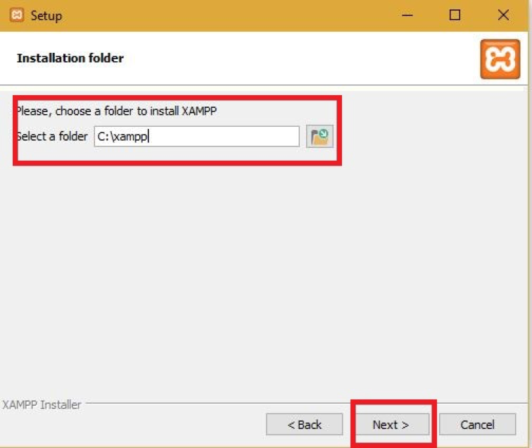

6. Unselect the Learn more about Bitnami for XAMPP option and click the **Next** button.

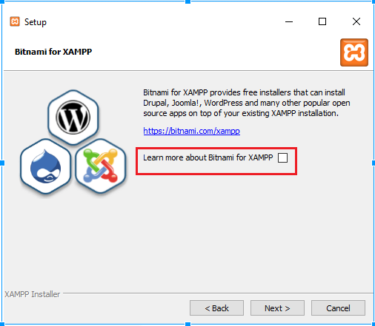

1. Click the **Next** Button.
2. Click the Allow access button to allow the app through the firewall (if applicable).
3. Click the **Finish** Button.

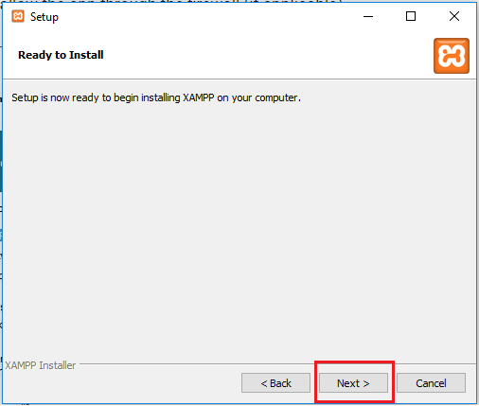

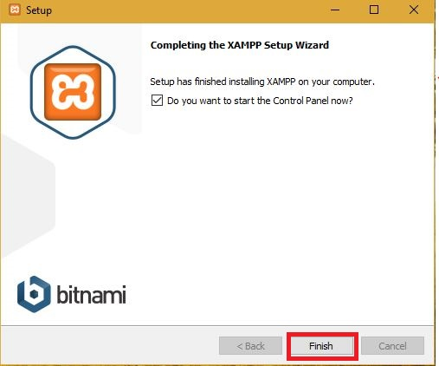

1. Choose your language (English or German).
2. Click **Save** button.
3. The following popup will open after clicking on Save button:

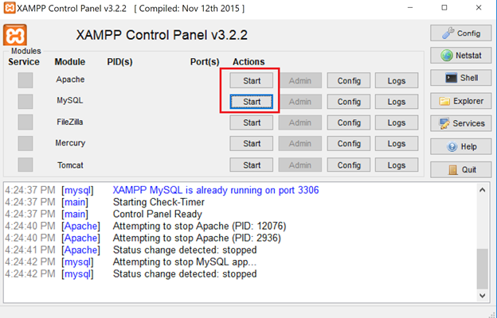

1. Now Click on Start button under Actions for Apache and MySQL modules both. 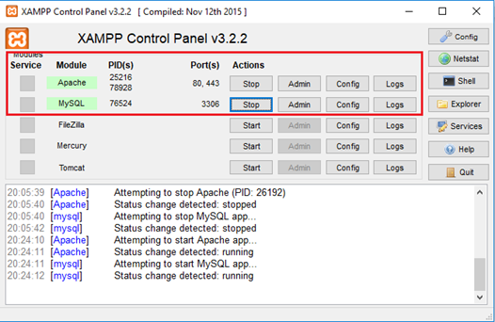
2. Xampp server is now up and running.

**Configure Xammp for Windows**

The following modules Apache, MySQL etc are there. Start Apache and MySQL to run the project.

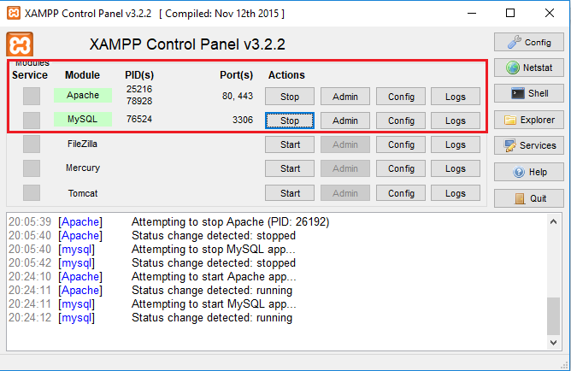

**Deployment of the project:**

1. The first step is to open xammp and start Apache and MySQL services.

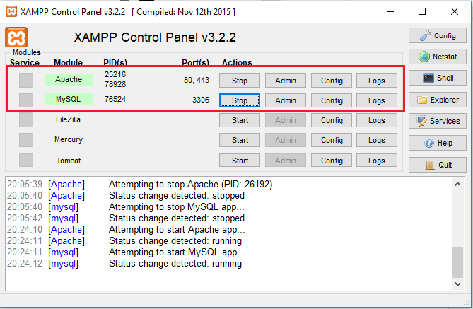

1. Click on the Admin button of the Apache service.

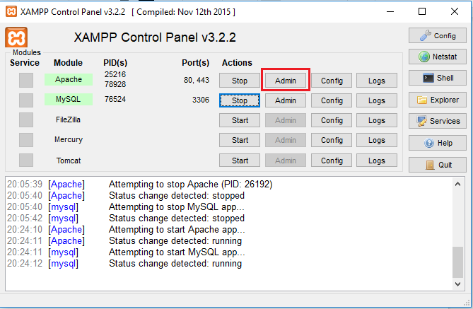

1. The following page opens in the default browser. (Better to use Google Chrome)

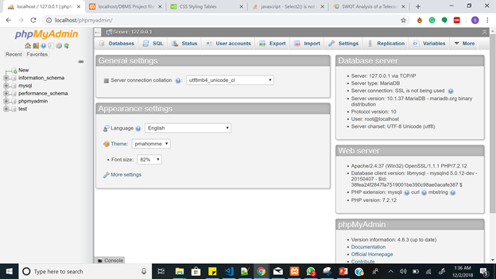

1. Click on **New** button to create a new database

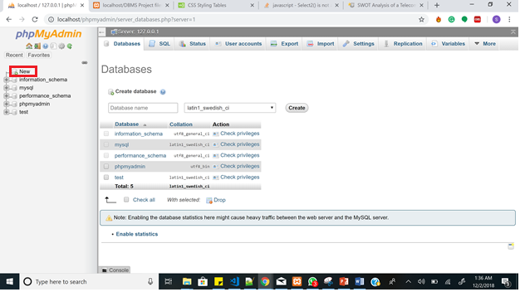

1. Create a database named “mysmith” and select “Collation” in the Collation dropdown list.

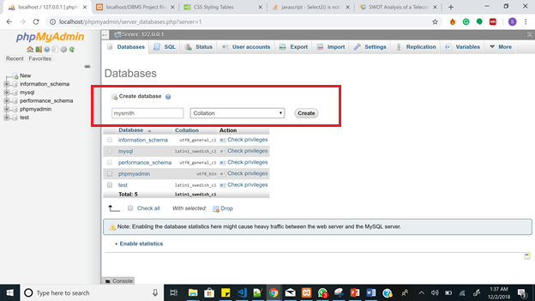

1. After creating the new database, click on the database and then click on the import tab.

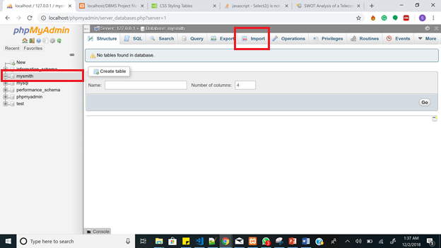

1. The import tab opens up.

Under the 'File to import' section, click Browse and locate the file with the Project0504-10_mysmith.sql extension you wish to import.

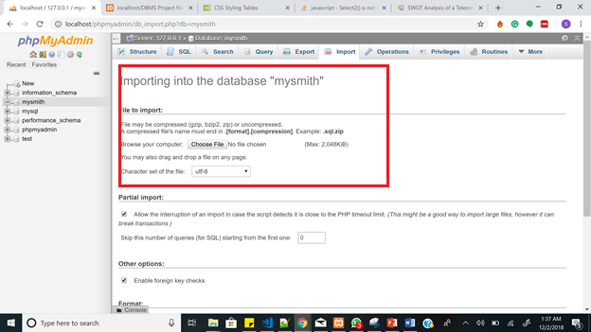

1. Check or uncheck the boxes for 'Partial import' and 'Other options'.  
   From the 'Format' dropdown menu choose 'SQL'.  
   Click the Go button at the bottom to import the database.

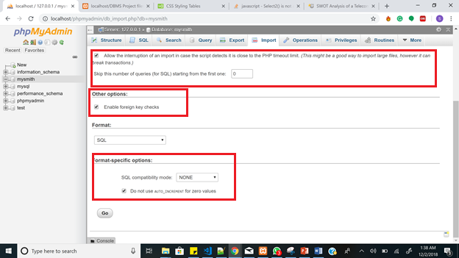

1. Since we have imported a database, all tables will show when selecting the database in the left panel of phpMyAdmin.

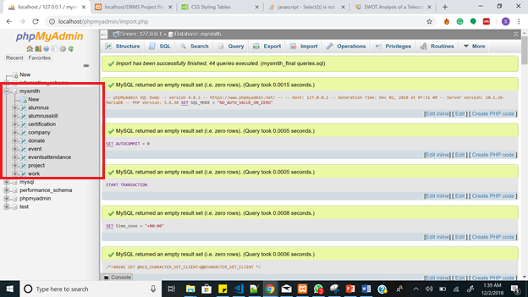

**Steps to run the project**:

1. Once xampp is installed, navigate to the location of the xampp folder. If you have chosen the default location, then the xampp will be in C:\xampp.
2. In the xampp folder, locate the ‘htdocs’ folder. (eg: C:\xampp\htdocs)

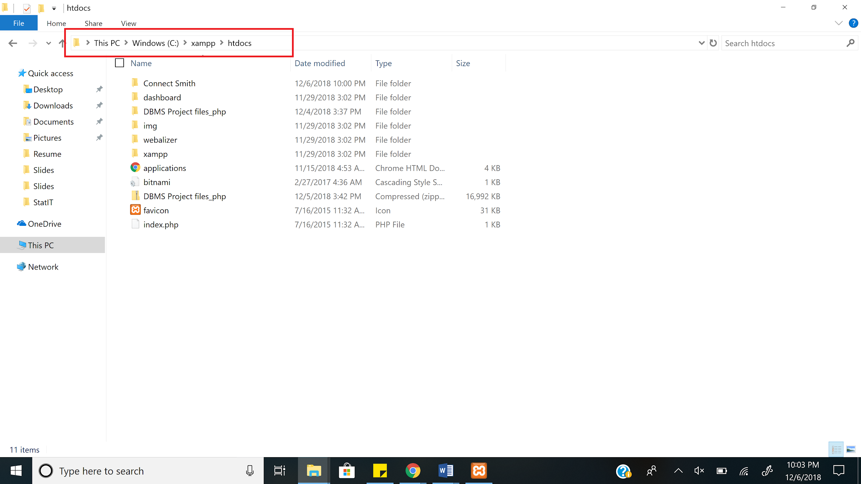

1. Inside the htdocs folder, copy and paste the ‘Connect Smith’ folder(which has the actual project) in it. You can create another folder and paste it inside it also. For this project, the project folder name uploaded and downloaded is Connect Smith. So paste, Connect Smith inside it.

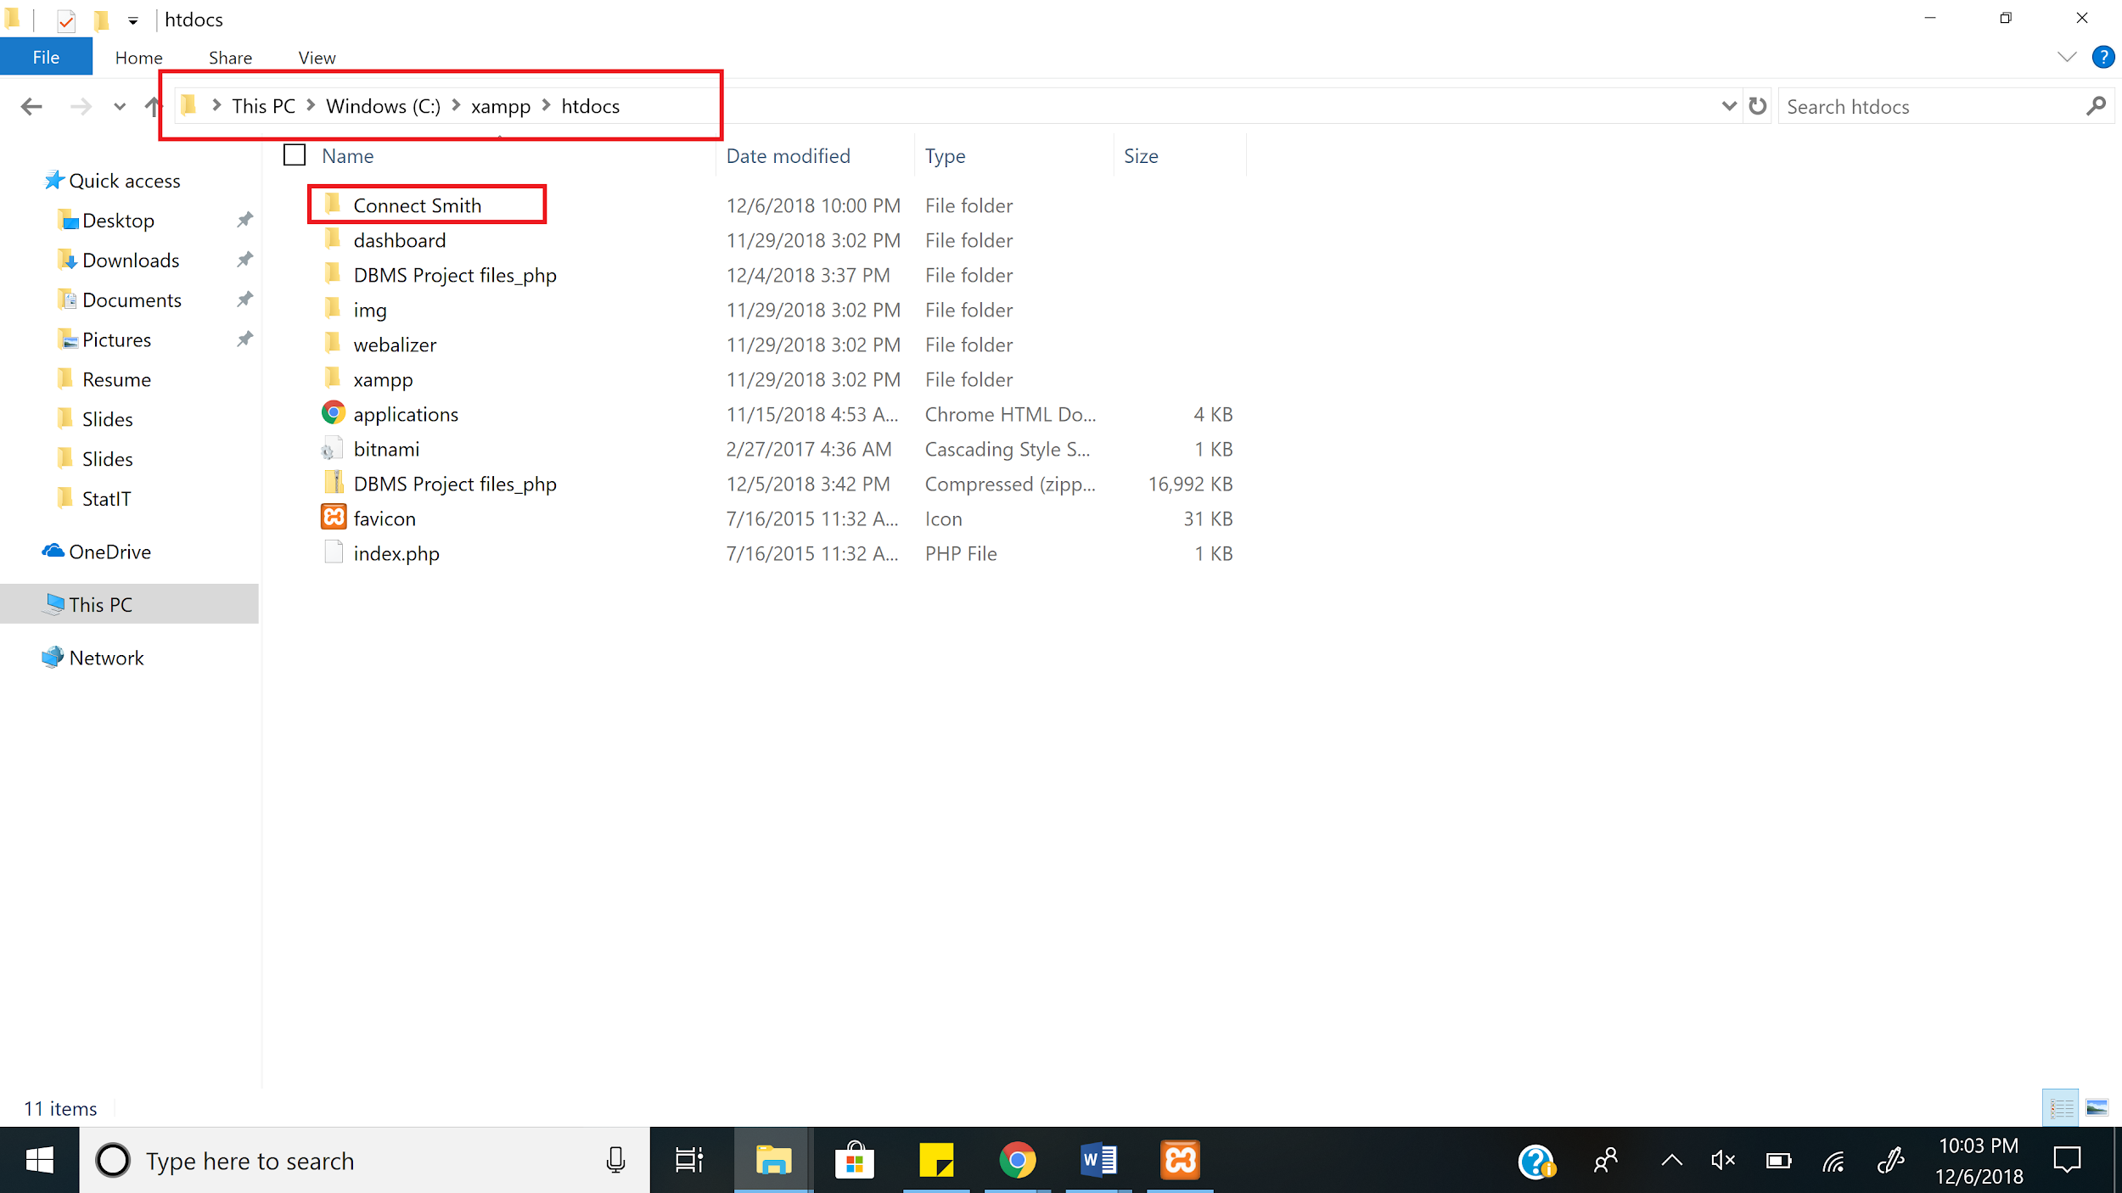

1. The index.html is the homepage.

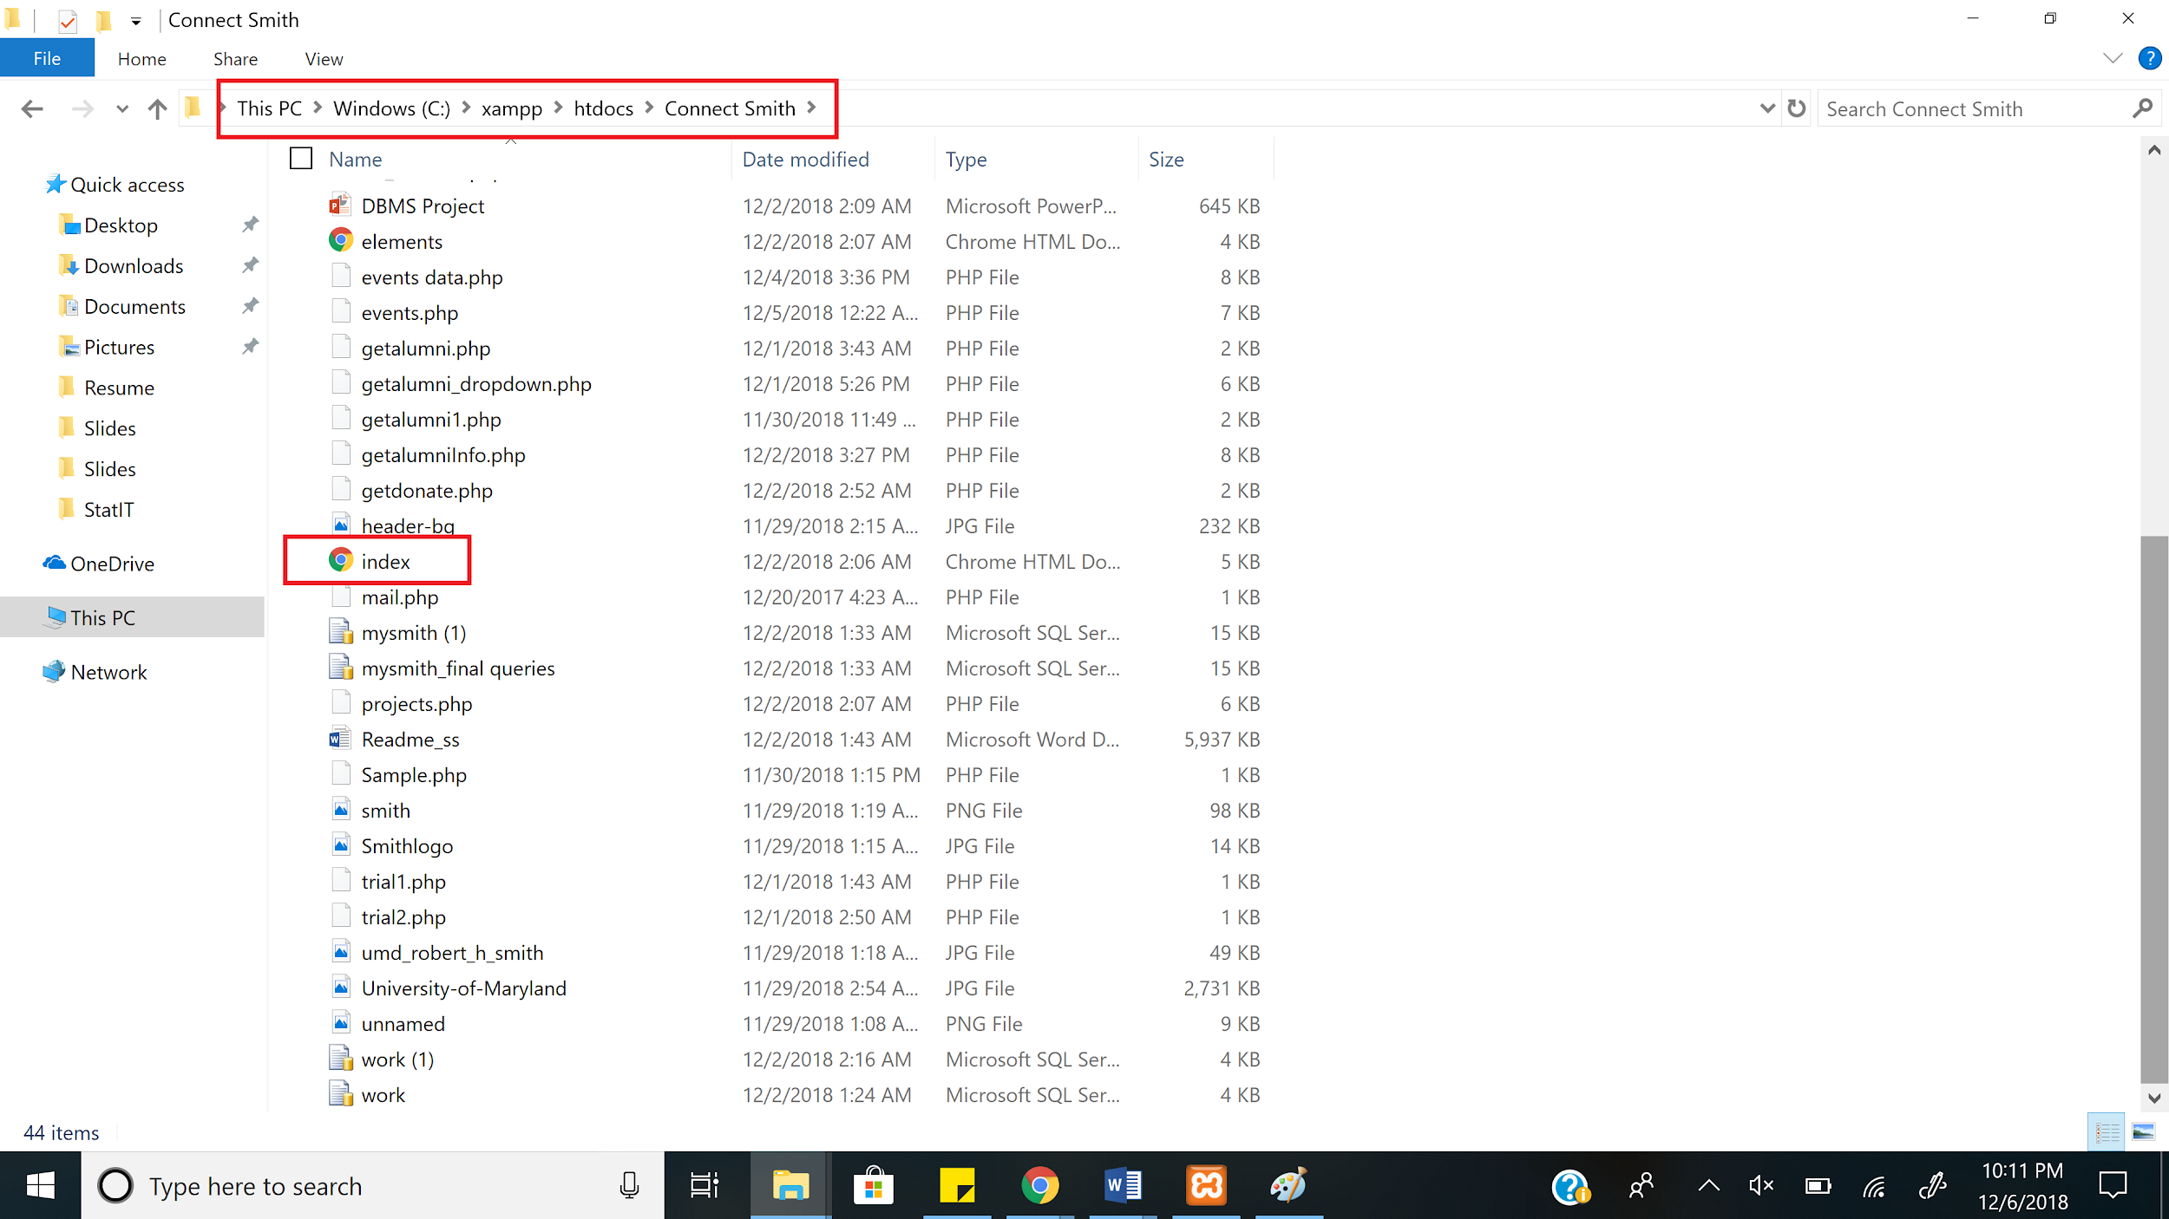

1. Open browser(Google Chrome), and type localhost/Connect Smith/index.html.

If the folder name is different, type localhost/Folder_name/index.html

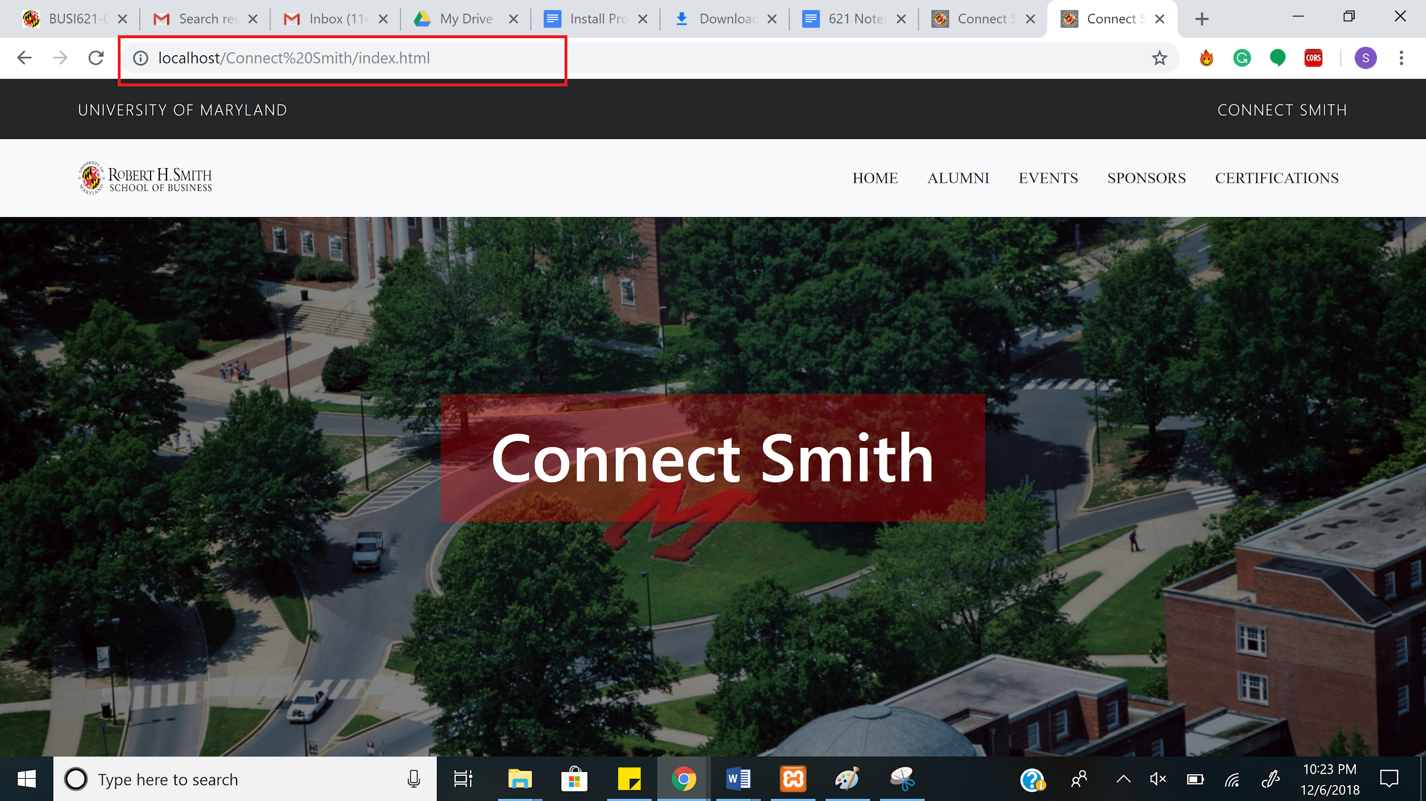

## Data Sources:

**Functionalities of Connect Smith:**

* 1. When you run the project in web browser, the home page is display. User can navigate to home page from elsewhere by clicking on the HOME tab.

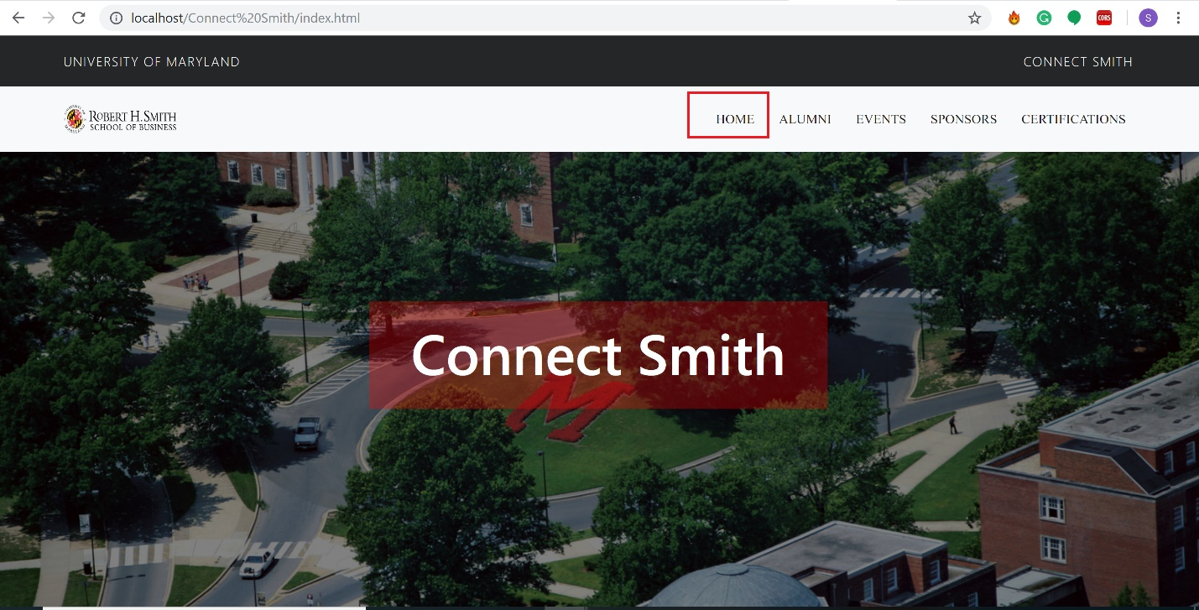

* 1. By clicking on the ALUMNI, user can select the year, company, role of the alumni that he/she wants to view.

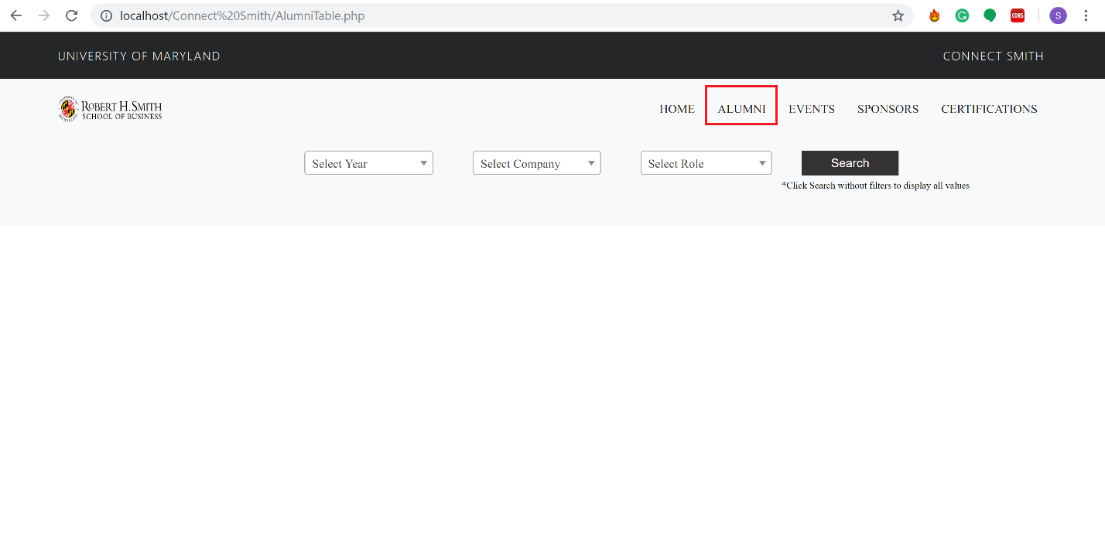

* 1. Click on the search button to display details of alumni after selecting the filters.

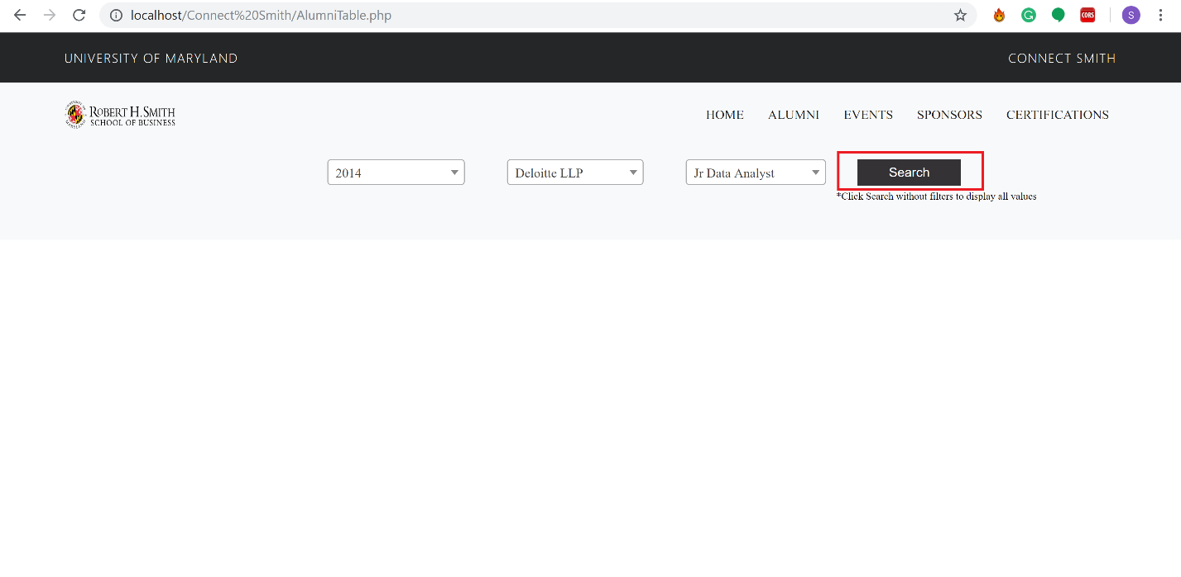

* 1. 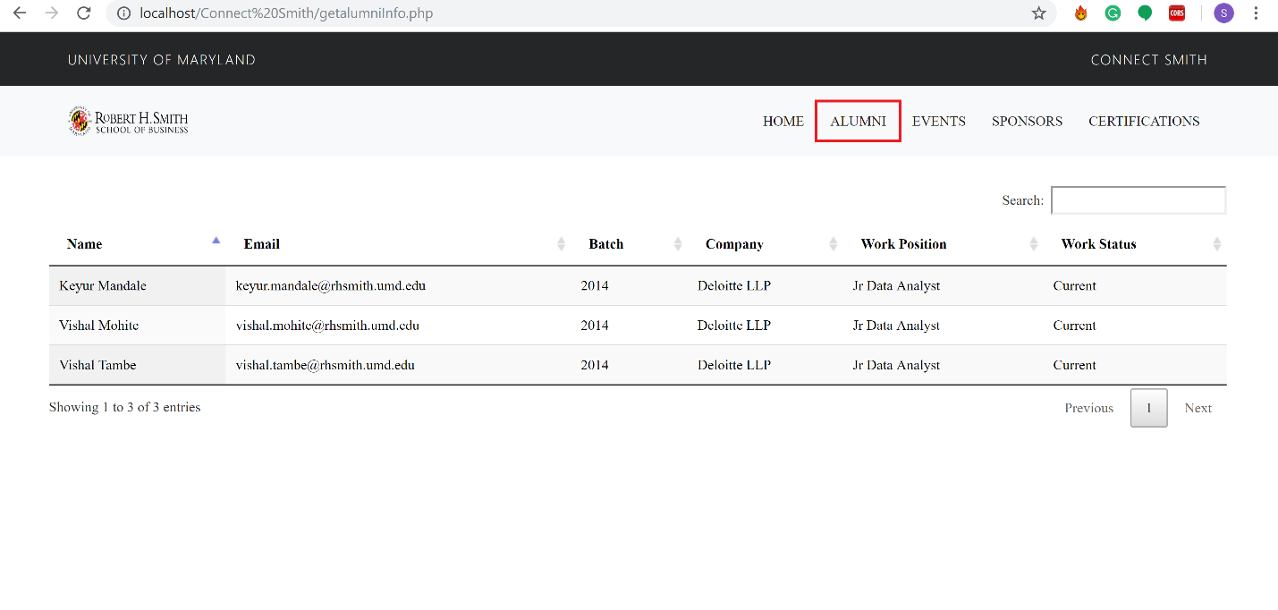All the details of the alumni are displayed in the alumni tab.

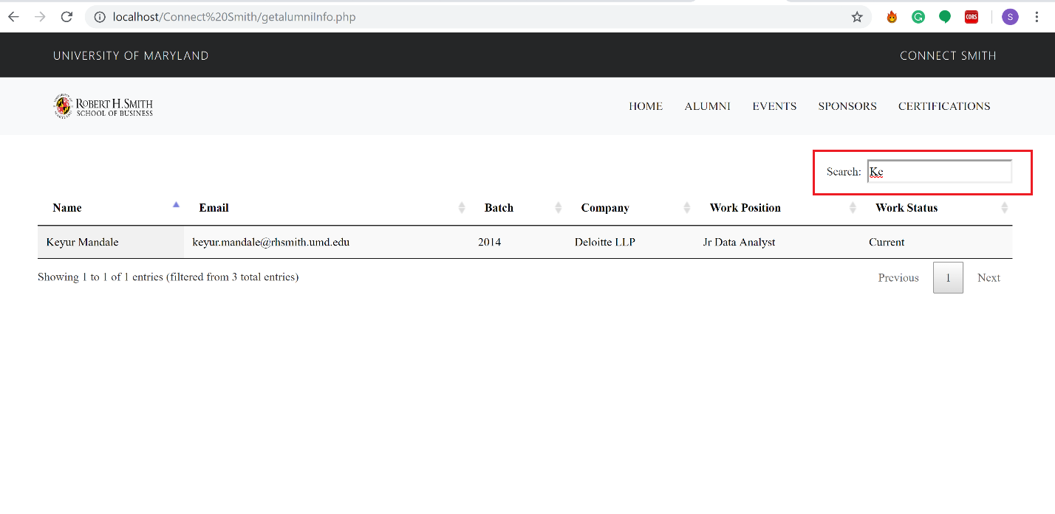

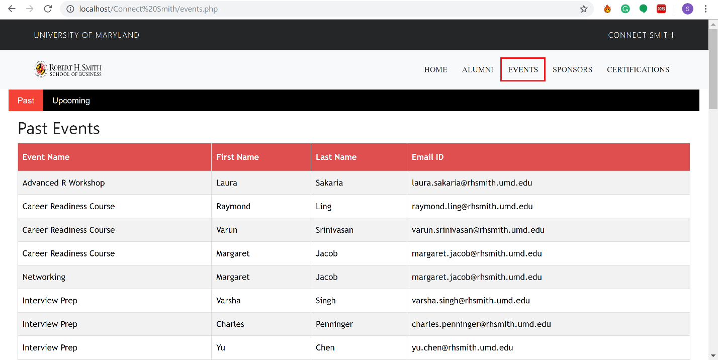

5. In the Events tab, the past and the upcoming events can be viewed along with the alumni details attending the respective events

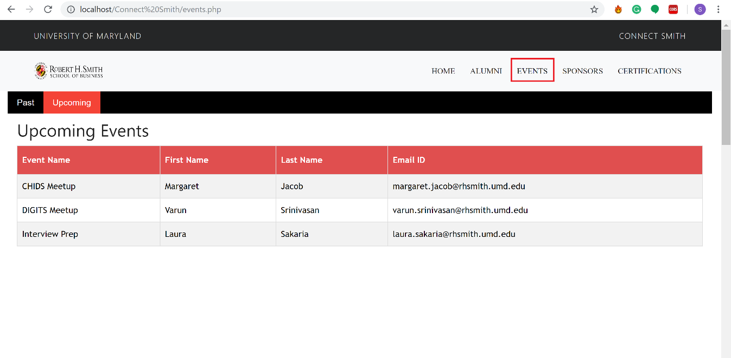

1. In the sponsors tab, projects sponsored by alumni can be viewd. Here Smith Alumni Management project and its alumni details are displayed.

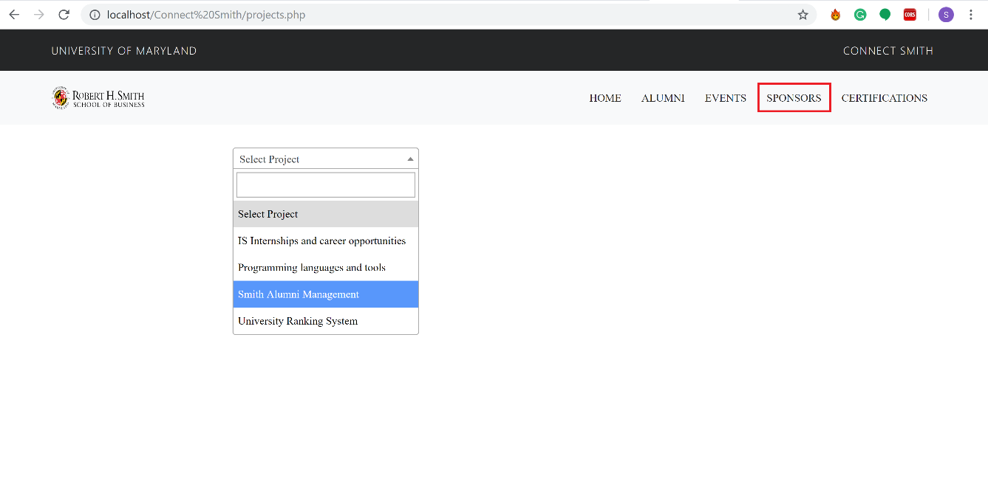

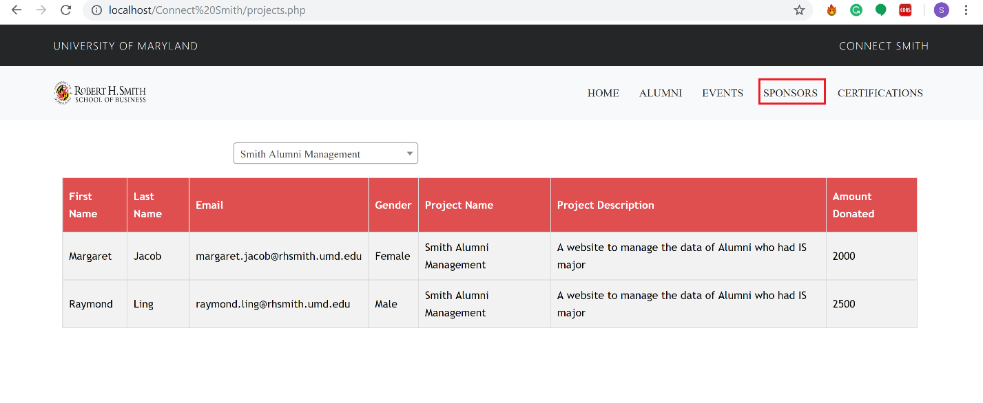

1. In the certifications tab, certifications done by alumni and its count can be viewd.

